NEWSLETTER

No. 04, Term 01, Week 07

Monday 12 March 2018

Greetings, Kia ora, Talofa lava, Kia orana, Malo e lelei, Fakalofa Lahi Atu, Namaste, An Young Haseyo, Konichiwha, Bula Vinaka, Sawadee, Dobra Dan, Ni Hao, As-salamu alaykum, Hola

From the Principal – Mrs. Watts

Air Force Visit
On Friday, we had a special visit from some members of the NZ Defence Air Force crew. The children had a lot of fun watching the helicopter land and take off and were delighted to spend time looking through the helicopter and speaking with members of the defence force. We were lucky enough to have some members of the recruiting team speak to our senior students who might be thinking of this as a possible career pathway.

ASB Banking
We can now offer school banking. Banking day is on Friday. Forms are located on the Kashin the Elephant bank deposit box in our reception area. When children sign up to open an ASB account, they will be sent a Kashin deposit box and calculator in a yellow bag - all to keep. If you’d like to register your child for free, for this, please see our friendly office staff.

GETWISE - FINANCIAL LITERACY
Today we had Marlon from Getwise come into our school to teach classes about money and needs versus wants. Children had a great time learning with him.
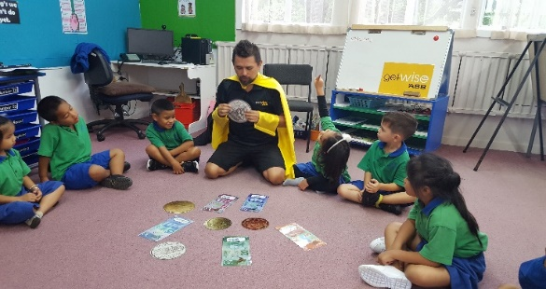

Hippy
Hippy is a home based programme run by friendly tutors who will model learning strategies that you can use with your pre-schoolers to prepare them for starting school. If you’re interested, please see our office staff. https://www.greatpotentials.org.nz/hip.

SPORTS NEWS

Gymnastics
This is the last week of Gymnastics for our year 0-5 students. Students have enjoyed learning from the Gymnastics Instructor Kayne. They had their assessments last week and were awarded wristbands in Gold, Silver and Bronze for their efforts.

Kung Fu Classes
The Kung Fu School has a new club in Mt Wellington operating now! Classes are held in our school hall and are for Students aged 7 and up.
Classes are currently Wednesdays at 6:15 pm to 7:15 pm.
Parents are welcome to attend and the first class is free.
Benefits of training in Shaolin Kung Fu include increased: fitness, self-defence, confidence, discipline focus and many more.
Visit our website www.shaolinkungfu.co.nz

Rippa Rugby
Last Friday was our 2nd Friday of competition at Hamlin Park. Next Friday 23 March will be the last round of games - this will end with a prize giving for year 7 and 8s. We have 2 year 5/6 teams and 2 year 7/8 teams representing our school. Games start at 3:45pm. Come to Hamlin Park and support PDS. Below are some photos of the children training for their Friday game.

Winning House
Congratulations Kowhai House - the winning house for the week.
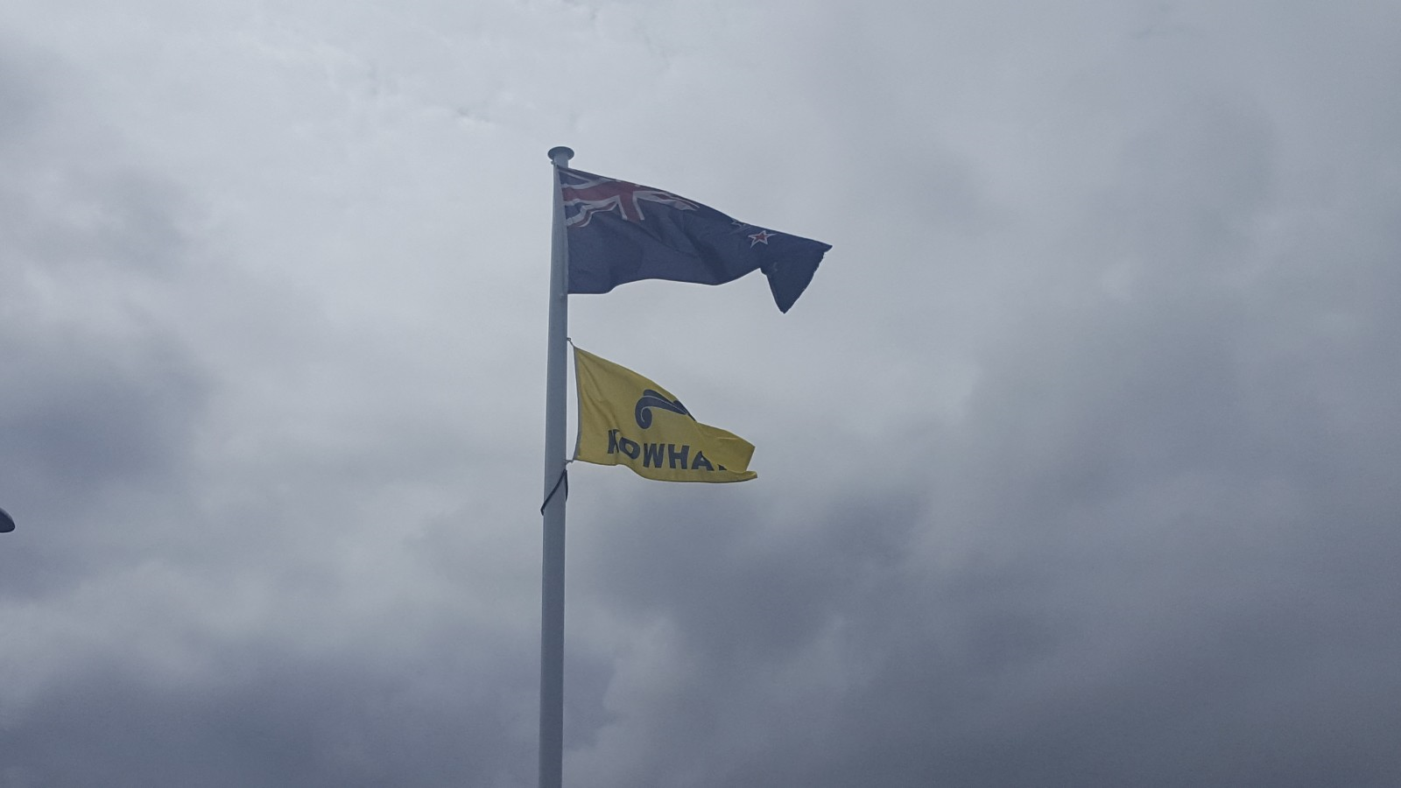

UPCOMING EVENTS
Friday 23 March - Singing Assembly at 2.00pm in the school hall.

Wednesday 21 March
School Social
Hui/Fono Family Evening
More Information to come your way
Friday 23 March
Mufti Day Fundraiser
School Singing

Friday 6th April - PDS Open Day. Come and see learning in action! We’d like to extend an invitation to friends and whanau to come in and have a look at PDS learning in action. Children would love to share their learning with you.

Merit Awards
Room 1 -
Varun Sureddi for being a responsible class helper.
Jorjah-Pearl Ngaia for being a responsible class leader and monitor.

Room 2 -
Jayla Aselemo for talking about own learning and thinking with her parents.
Alliyah Abadiano for talking about own learning and thinking with her parents.

Room 3 –
Uini Tai for modelling RISE and making good choices and decisions.
Tamatea Turua for using his attack skills during reading time to work out new words.

Room 05 –
Razel Padayao for elaborating her ideas that can describe explain the ideas more.
Ana Kaufusi for her great improvement in looking for keywords in the text to help her identify the main ideas.

Room 07 –
Niukasela Phillips for showing her good manners and being helpful in the classroom.
Kanye Cummings for exhibiting positive outlook and attitude in the classroom.

Duffy Awards
Serenity Potts for learning to be a positive leader.

Sione Ofakineiafu for trying hard to read his stories.

Elza Sok for learning letter name and sounds for “Satp”

Pakieli Havili-Kaufusi for confidently sharing his learning with his parents.

Environmental Award:
Room 7 – for having a tidy and presentable classroom area.

